Proposal for a Risk Indicator in Alignment with the Danish Pesticide Load Indicator

Inhaltsverzeichnis

1. Calculation of the *PLI-EU* 3

1.1. PLI-EU on field or farm level. 3

2. Modified Pesticide Load Index for Europe 4

2.1. Fate metrics 4

2.2. Ecotoxicity metrics 5

2.3. Human health metrics 7

2.4. Standardisation of the pesticide load indices 8

2.4.1. Standardisation of fate metrics 8

2.4.2. Standardisation of ecotoxicity load metrics 11

2.4.3. Indicator for human health 14

2.5. Aggregation of the PLI 16

2.5.1. Aggregation of the ecotoxicity load metrics 16

2.5.2. Aggregation of the fate load metrics 17

2.5.3. Aggregation of the human load metrics 18

2.6. Database for active substances used for the PLI-EU calculation: PPDB vs. EFSA 18

3. *PLI-EU* on national level to derive national risk trends 19

3.1. Based on sales data of active substances 19

3.2. Based on sales data and the AI specific registered application rate. 19

4. Appendix 20

4.1. Comparison of toxicity metrics with PLI-EU values based on different reference values 20

4.1.1. PLI-EU with minimum as reference value 20

4.1.2. PLI-EU with 1th percentile as reference value 21

4.1.3. PLI-EU with 10th percentile as reference value 22

4.2. Summary of all metrics 23

References 26

1. Introduction and Context

Todo: Replace risk with potential risk

risks.

The indicator presented here was developed for pesticide assessment at the European level. It aligns with the Danish Pesticide Load Index (*PLI*) and is referred to as the Pesticide Load Indicator (Europe) (*PLI-EU*). The *PLI*, was introduced as a new metric designed to assess the environmental and health impacts of pesticide use in Denmark by the Danish Environmental Protection Agency (2012). It provides detailed methodologies for calculating the PLI, incorporating factors related to human health, ecotoxicology, and environmental fate of pesticides. The report also discusses how the PLI serves as an enhancement over the previous Treatment Frequency Index (TFI), offering a more nuanced understanding of potential pesticide risk r Kudsk et al (2018) published the PLI as R-package.

Unlike the PLI, the proposed indicator does not incorporate predefined load factors. For instance, in the PLI, a load factor of 100 is applied to the sub-indicator for bees, placing a stronger emphasis on active substances that pose significant risks to pollinators.

Additionally, the *PLI-EU* integrates a broader range of active substance metrics and toxicity values for various reference organisms, enhancing the representation of risks related to environmental behaviour and toxicity.

1. Calculation of the PLI-EU

This chapter provides a comprehensive overview of the methodological approaches employed in the calculation of the Pesticide Load Indicator (PLI-EU) across various spatial scales. In addition, it details the procedure for calculating the PLI-EU for the individual active substances.

The calculation of the PLI-EU relies on a standardized and comprehensive database containing information on active substance properties and toxicity values. In this study, the Pesticide Properties Database (PPDB; Lewis et al., 2016) was utilized as the primary data source, ensuring consistency with the original PLI methodology and enabling access to a wide range of parameters beyond ecotoxicological endpoints.

Although the PPDB serves as the central reference in the current framework, it is important to recognize the relevance of alternative data sources, such as the EFSA OpenFoodTox (Drone et al. 2021) database and the EPA CompTox Chemicals Dashboard (Williams et al 2017). These resources may help address existing data gaps within the PPDB and hold potential for future integration. In the long term, the adoption of an officially recognized and regularly maintained database would represent a significant step toward enhanced standardization and institutional endorsement of the PLI methodology.

* 1. Spatial scales of application

The indicator presented here was developed for pesticide assessment at the European level. It aligns with the Danish Pesticide Load (PL-DK) and is referred to as the Pesticide Load Europe Index (PLI-EU). The PLI-EU, was developed and introduced as a new metric designed to assess the environmental and health impacts of pesticide used in EU Members States. It provides detailed methodologies for calculating the PL, incorporating factors related to human health, ecotoxicology, and environmental fate of pesticides. The PL is based on the inherent chemical properties of active ingredients

The proposed PLI-EU can be used to analyse different cropping strategies at various scales—field, farm, regional, and member state levels. When applied at the field or farm level, detailed field-specific data on pesticide use is necessary. However, because not all member states have comprehensive pesticide usage reporting systems, the field- or farm-level application of the PLI-EU is primarily suited for comparing different cropping strategies for a specific crop on a given field, rather than for assessing the overall pesticide-related risk at the member state level.

Applying the PLI-EU indicator over successive years on the same field enables an assessment of the impact of entire crop rotations. To support this, field-specific pesticide application calendars are required in order to appropriately weight the PLI scores according to the applied doses of active substances (see Section 1.1).

At broader scales—regional or national—the PLI-EU can be applied using national-level sales data of active substances. This approach is particularly valuable for evaluating pesticide-related risk trends across EU member states. For such analyses, reliable national sales data on active substances are essential (see Section 3).

* + 1. PLI-EU on field or farm level

At the field or farm level, the PLI-EU is calculated by multiplying substance-specific risk indices with the corresponding application rates (*ARAS*). These values are then aggregated by summing all applications on the field over a single growing season or an entire crop rotation, using a weighted approach. This aggregation can be performed either separately for individual substance groups—such as herbicides, insecticides, fungicides, and other pesticides—or as a single overall value encompassing all groups.

where:

Sum of risk indices weighted by application rates for all active s substances applied on a specific field [load/ha]

Application rate of an active substance [kg/ha]

Risk index of an active substance [load/kg]

*PLI-EU* on national level to derive national risk trends

* + 1. PLI-EU on national level

The following three sections present a methodological framework for quantifying pesticide-related risks at the European level using the Pesticide Load Indicator (PLI-EU). Each section outlines a distinct approach to integrating pesticide sales data with risk indices, aiming to enhance comparability and reliability of pesticide risk assessments across EU Member States.

The first section introduces a baseline methodology in which substance-specific PLI-EU values are multiplied by annual sales volumes of the respective active substances. However, this method does not account for the actual intensity of use, potentially limiting its interpretive depth.

The second section addresses this limitation by incorporating application intensity into the calculation. Given the difficulty of accessing harmonized application rate data across the EU, a simplified proxy is proposed: dividing total sales volume by the utilised agricultural area (UAA) or arable land per country. While this method introduces assumptions—particularly for substances used outside traditional agricultural settings—it offers a more feasible and consistent alternative to using detailed product-specific application rates.

The third section refines the assessment further by integrating registered application rates (RAR) from national databases, specifically those maintained by the German Federal Office of Consumer Protection and Food Safety (BVL). Here, substance-specific average application rates are used to estimate the treated area, allowing for a more accurate adjustment of risk indices. This method reflects the relative intensity of each active substance more precisely, particularly emphasizing those with low standard application rates, such as insecticides.

Collectively, these sections advance a tiered approach to calculating the PLI-EU, progressing from basic risk quantification based on sales data to more nuanced methodologies that incorporate spatial and intensity factors. This progression enhances the capacity to perform harmonized, EU-level assessments of pesticide use and its associated risks, while also identifying practical limitations and proposing viable solutions for broader methodological adoption.

* + - 1. PLI-EU based on sales data

The *PLI-EU* trend on national level is determined by multiplying the substance-specific risk indices with the annual sales volumes of the respective active substances (S*AS*). These values are then aggregated as a weighted sum per year, either for individual substance groups (herbicides, insecticides, fungicides, and other pesticides) or as an overall value for all substance groups.

where:

Sum of risk indices weighted by sales volume for all active substances sold per year [kg*load]

Annual sales volume of an active substance [kg]

Risk index of a single active substance [load]

* + - 1. Based on sales data and the AS specific registered application rate.

Multiplying risk indices by sales figures does not account for the actual intensity of active substance application. To address this limitation, the registered (standard) application rate () of plant protection products (PPPs) containing the respective active substance can serve as an indicator of application intensity. Product-specific standard application rates can typically be obtained from national sources, such as the approval database of the German Federal Office of Consumer Protection and Food Safety (BVL, 2019).

However, the use of registered application rates at the EU level poses challenges, as such data are not uniformly available or harmonized across all Member States. Given the objective of developing a methodology that is applicable EU-wide, reliance on national-level approval databases may hinder broader implementation.

The standard application rates of all products containing a specific active substance were converted into substance-specific standard application rates and summarized as an average value ().

The German Environment Agency (UBA) has proposed adjusting the calculated risk indices by dividing them by the standard application rates of active substances () [kg/ha]. This approach expresses the application intensity of each active substance as a hectare dose (1/) [ha/kg].

The value obtained by dividing sales figures by the average ( ) [ha] represents the total area treated with the active substance, assuming one application per unit area.

where:

Sum of risk indices weighted by sales volume and standard application rate for all active substances sold per year [ha-1*load]

Annual sales volume of an active substance [kg]

Risk index of an active substance

Average standard application rate of active substances [kg/ha]

The calculation method described here places greater emphasis on active substances with a low RAR. For example, insecticides, which typically have a low RAR, will receive higher weights, leading to different national risk trends compared to the method outlined in section 3.

* + - 1. PLI-EU based on sales data and AS specific application rates

As a more pragmatic and consistent alternative, we propose the use of a simplified proxy: dividing the total quantity of active substance sales (in kg) by the utilised agricultural area (*UAA*) or arable land within each country. Although this approach has limitations—particularly for substances primarily applied in greenhouses or on non-agricultural land—it offers a more feasible and harmonized method for estimating application intensity across the EU. Furthermore, it circumvents the need for detailed product-level approval data, which is often difficult to access or compare across Member States.

where:

Sum of risk indices weighted by sales volume and utilised agricultural area for all active substances sold per year [load*kg/ha]

Annual sales volume of an active substance [kg]

Risk index of an active substance [load]

utilised agricultural area [ha]

The calculation method described here places greater emphasis on active substances with a low RAR. For example, insecticides, which typically have a low RAR, will receive higher weights, leading to different national risk trends compared to the method outlined in section 3.

* 1. Calculation of the PLI-EU for active substances

To calculate the PLI on European level all active substances were considered that were approved and sold in since 2011. HRI 1 is based on data on pesticide sales reported to the Commission by Member States under [Regulation (EC) No 1185/2009](https://eur-lex.europa.eu/eli/reg/2009/1185/oj). In total there were **504 active substances** listed in the SUR from which 467 could be linked to the PPDB. S

The basis for calculating risk trends, in addition to the sales figures of pesticide active substances, is a comprehensive and complete database of active substance properties and toxicity values. For the calculation of the indicators presented here, the Pesticide Property Database (Lewis et al., 2016) was used as a standardized data source. An alternative data source for the AS parameters could be the EFSA data base (Drone et al. 2021).

The risk indicator for pesticides () is divided into three sub-indicators: human health (*Health*), environmental behavior (*EFate*), and environmental ecotoxicity (ETox). These indicators are further broken down into sub-indicators based on specific active substance metric. A detail description of the aggregation of the single AS indicator *PLIAI i*s given in section 2.4.3.

The PLI-EU of each metric for an individual active ingredient (*PLIAI*) is standardized, so the values will range between zero and one. A detailed description of the standardization of the indices is given in 2.3 in section.

* + 1. Fate metrics

The fate metrics considered in the PLI-EU are presented in Table 1. In addition to the original fate metrics of the PL-DK(Kudsk et al., 2018,), other metrics such as degradation in water (*DT50Water*) could also be included to assess persistence. In the original PLI, only soil degradation (*DT50soil*) was used to describe persistence. In PLI-EU, the average of these two metrics was employed as the load index for persistence. Kudsk et al. (2018) used SCIGROW as the leaching potential metric instead of GUS. In the new indicator, SCIGROW was chosen as metric for mobility.

In the UK, work was also carried out to develop a UK pesticide load (PL-UK), (Rainford et al.) also based on the PL-DK like the PL-EU, and for the sake of comparison, the metrics included in the PL-UK are also shown in Table 1.

Table 1: Fate metrics

|  |  |  |  |  |  |  |  |  |  |
| --- | --- | --- | --- | --- | --- | --- | --- | --- | --- |
| Metric | Description | Units | Max. | Min. | metric values available | coverage. with values | Kudsk et al | Rainford et al. | PLI-EU |
| Total number |  |  |  |  | **467** |  |  |  |  |
| DT50soil | Persistence in soil is measured by DT₅₀, the time for a substance's concentration to decrease by 50%. Lab values are used for all AI | days | 1587 | 0,001 | 314 | 67,2% | **yes** | **yes** | **yes** |
| DT50water | Persistence in water is measured by DT₅₀, the time for a substance's concentration to decrease by 50%. | days | 1000 | 0,020 | 306 | 65,5% | no | no | **yes** |
| SCIGROW | The SciGrow evaluate the likelihood of **groundwater contamination**. It is a model used to estimate the potential of a substance to reach groundwater. It is based on physicochemical properties such as sorption (Koc) and degradation (DT₅₀), along with standardized environmental scenarios. It evaluate the likelihood of groundwater contamination. | μg l⁻¹ | 29,5549 | 0,000 | 287 | 61,5% | **yes** | no | **yes** |
| BCF | Bioaccumulation refers to a substance's tendency to concentrate within the tissues of organisms through chemical partitioning from water into an organic phase (e.g., fish tissue), measured in liters per kilogram (L/kg). When bioconcentration factor (BCF) data is unavailable, it is estimated using the log₁₀ of the octanol-water partition coefficient (log Kow). | l kg⁻¹ | 26858 | - | 327 | 70,0% | **yes** | **yes** | **yes** |
| KOC | Mobility is a substance's tendency to reach surface water, measured by the organic carbon sorption coefficient (Kfoc/Koc), with Kfoc preferred and Koc used if unavailable. | mL g⁻¹ | >100000 | 0,1 | 304 | 65,1% | **yes** | **yes** | Yes |

* + 1. Ecotoxicity metrics

Table 2 presents an overview of the possible eco-toxicological metrics used for PLI-EU which could be used for calculation across 467 substances. It includes key information such as the range of metric values, data availability, and inclusion in previous studies (Kudsk et al. and Rainford et al.).

Most aquatic toxicity metrics (e.g., LC50 for fish, aquatic invertebrates, algae) have high data coverage (above 75%) and are included in both Kudsk et al. and Rainford et al. Similarly, terrestrial toxicity metrics like LD50 for birds, mammals, and bees also show high availability and inclusion.

Some metrics, such as those for sediment organisms, non-target plants, and certain beneficial insects (e.g., bumblebees, mason bees, ladybirds), have low data availability—often below 30%—and are not included in earlier frameworks but could be considered in the PLI-EU model.

Table 2: Ecotoxicity metrics

| **Metric** | **Description** | **Units** | **Min.** | **Max.** | **metric values available** | **Perc. with values** | **PL-DK** | **PL-UK** | **PL-EU** |
| --- | --- | --- | --- | --- | --- | --- | --- | --- | --- |
| Total number |  |  |  |  | 467 | 100% |  |  |  |
| LC50_FISH | Lethal concentration for 50% of fish population | mg l⁻¹ | 0,000035 | 10000 | 421 | 90,1% | **Yes** | **Yes** | **Yes** |
| LC50_AQU_INVERT | Lethal concentration for 50% of aquatic invertebrates (water fleas, aquatic invertebrates). | mg l⁻¹ | 0,000022 | 10000 | 423 | 90,6% | **Yes** | **Yes** | **Yes** |
| LC50_SEDIMENTORG. | Lethal concentration for 50% of sediment-dwelling organisms (benthic species). | mg l⁻¹ | 0,000013 | 719 | 75 | 16,1% | No | No | **Yes** |
| LC50_ALGAE | Lethal concentration for 50% of algae population (toxicity to primary producers). | mg l⁻¹ | 0,00004 | 3000 | 412 | 88,2% | **Yes** | **Yes** | **Yes** |
| EC50_LEMNA | Effective concentration for 50% of Lemna (duckweed) population (growth inhibition). | mg l⁻¹ | 0,00011 | 301 | 258 | 55,2% | No | No | **Yes** |
|  |  |  |  |  |  |  |  |  |  |
| NOEC_FISCHE | No Observed Effect Concentration for fish | mg l⁻¹ | 0,000004 | 10000 | 349 | 74,7% | **Yes** | **Yes** | **Yes** |
| NOEC_DAPHNIA | No Observed Effect Concentration for Daphnia | mg l⁻¹ | 1,3E-06 | 420 | 340 | 72,8% | **Yes** | **Yes** | **Yes** |
| NOEC_SEDIMENTORG | No Observed Effect Concentration for sediment organisms. | mg l⁻¹ | 0,000031 | 1000 | 175 | 37,5% | No | No | **Yes** |
|  |  |  |  |  |  |  |  |  |  |
| LC50_EARTHWORM | Lethal concentration for 50% of earthworm population | mg kg⁻¹ | 0,855 | 6720 | 384 | 82,2% | **Yes** | **Yes** | **Yes** |
| NOEC_EARTHWORM | No Observed Effect Concentration for earthworms (chronic soil toxicity) | mg kg⁻¹ | 0,0336 | 3550 | 281 | 60,2% | **Yes** | **Yes** | **Yes** |
| NOEC_OTHER_SOILORG | No Observed Effect Concentration for other soil organisms (e.g., collembolae) | mg kg⁻¹ | 0,004 | 5000 | 169 | 36,2% | No | No | **Yes** |
|  |  |  |  |  |  |  |  |  |  |
| LD50_BIRDS | Lethal dose for 50% of bird population | mg kg⁻¹ | 0,8 | 20000 | 404 | 86,5% | **Yes** | **Yes** | **Yes** |
| NOEL_BIRDS | Birds - Chronic 21d NOEL | (mg kg⁻¹ bw d⁻¹) | 0,088 | 1440 | 219 | 46,9% | No | No | **Yes** |
| LD50_MAM_ORAL | Lethal dose for 50% of mammals via oral exposure. | mg kg⁻¹ | 0,672 | 20000 | 433 | 92,7% | **Yes** | **Yes** | **Yes** |
| NOEAL_MAM | Mammals - Chronic 21d NOAEL | (mg kg⁻¹ bw d⁻¹) | 0,3 | 4279 | 226 | 48,4% | No | No | **Yes** |
|  |  |  |  |  |  |  |  |  |  |
| LD50_BEE_CONT | Lethal dose for 50% of honeybees via contact exposure. | μg insect⁻¹ | 0,001 | 1200 | 375 | 80,3% | **Yes** | **Yes** | **Yes** |
| LD50_BEE_ORA | Lethal dose for 50% of honeybees via oral exposure (e.g., ingestion of contaminated nectar). | μg insect⁻¹ | 0,00184 | 2733 | 373 | 79,9% | No | No | **Yes** |
| LD50_BUMBLEBEE_CONT | Lethal dose for 50% of bumblebees via contact exposure. | μg insect⁻¹ | 0,02 | 1161,6 | 68 | 14,6% | No | No | **Yes** |
| LD50_BUMBLEBEE_ORA | Lethal dose for 50% of bumblebees via oral exposure. | μg insect⁻¹ | 0,005 | 1161,6 | 62 | 13,3% | No | No | **Yes** |
| LD50_MASONBEE_CONT | Lethal dose for 50% of mason bees via contact exposure. | μg insect⁻¹ | 0,031 | 480 | 25 | 5,4% | No | No | **Yes** |
| LD50_MASONBEE_ORA | Lethal dose for 50% of mason bees via oral exposure. | μg insect⁻¹ | 0,0003 | 125 | 10 | 2,1% | No | No | **Yes** |
|  |  |  |  |  |  |  |  |  |  |
| LR50_T_PYRI | Lethal rate for 50% of Trichogramma pyralidae (a parasitoid wasp species). | g/ha | 0,0006 | 10000 | 306 | 65,5% | No | No | **Yes** |
| LR50_A_RHOPA | Lethal rate for 50% of Aphidius rhopalosiphi (a parasitoid wasp attacking aphids). | g/ha | 0,01 | 10000 | 296 | 63,4% | No | No | **Yes** |
| LR50_P_CUPREUS | Lethal rate for 50% of Poecilus cupreus (a ground beetle species). | g/ha | 2,45 | 10000 | 56 | 12,0% | No | No | **Yes** |
| LR50_C_CARNEA | Lethal rate for 50% of Chrysoperla carnea (green lacewing, beneficial predator). | g/ha | 0,036 | 10000 | 94 | 20,1% | No | No | **Yes** |
| LR50_C_SEPTEMP | Lethal rate for 50% of Coccinella septempunctata (seven-spot ladybird, beneficial predator). | g/ha | 0 | 7296 | 51 | 10,9% | No | No | **Yes** |
|  |  |  |  |  |  |  |  |  |  |
| ER50_NTP1 | Effective concentration for 50% effect on non-target plants. | g/ha | 0,054 | 10000 | 121 | 25,9% | No | No | **Yes** |
| ER50_NTP2 | Effective concentration for 50% effect on non-target plants. | g/ha | 0,00127 | 10000 | 96 | 20,6% | No | No | **Yes** |

* + 1. Human health metrics

The possible human health metrics, which can be used in *PLI-EU* are listed in Table 3. This table summarizes six key metrics related to human health toxicity and exposure for 348 substances. The most widely available metric is LD50 for mammals via oral exposure, with 85% data coverage, followed closely by LD50 via dermal exposure (84%). These values indicate the dose required to cause death in 50% of test mammals and are commonly used in human toxicological risk assessments.

Metrics related to occupational exposure focus on the risks faced by people applying or handling pesticides. The AOEL (Acceptable Operator Exposure Level), which indicates the maximum safe daily exposure over the long term, has data available for 79.6% of substances. MAC (Maximum Allowable Concentration), which defines the highest safe concentration in workplace air, has data for only 16.7% of substances—highlighting a significant gap in air exposure data. These metrics are crucial for evaluating the safety of pesticide use in professional settings.

Consumer safety is primarily assessed through ingestion-based metrics. The ADI (Acceptable Daily Intake), representing long-term exposure safety through diet, is available for 77.9% of substances. The ARfD (Acute Reference Dose), which assesses short-term or one-time dietary exposure, is available for 51.7% of substances. These metrics are essential for evaluating residues in food and ensuring consumer protection.

General mammalian toxicity is captured by LD50 values, which measure the lethal dose required to kill 50% of test mammals. The oral LD50 has the highest data availability at 85%, while the dermal LD50 is nearly as complete with 84%. These endpoints are widely used in toxicology to assess the baseline hazard of substances to mammals.

Table 3: Human health metrics

| Metric | Description | Units | Min. | Max. | metric values available | Perc. with values | Kudsk et al | Rainford et al. | PLI-EU |
| --- | --- | --- | --- | --- | --- | --- | --- | --- | --- |
| Total number |  |  |  |  | 467 |  |  |  |  |
| AOEL | Acceptable Operator Exposure Leve: The maximum amount of a substance that a worker can be exposed to daily over a long period without harmful effects. | mg kg⁻¹ bw d⁻¹ | 1,2E-06 | 128 | 360 | 77,1% | no | no | yes |
| ARFD | Acceptable Operator Exposure Level: The estimated amount of a substance that can be ingested in a single day or meal without adverse health effects. |  | 0,0005 | 6,7 | 250 | 53,5% | no | no | yes |
| ADI | Acceptable Daily Intake: The estimated amount of a substance that can be ingested daily over a lifetime without significant health risk. | mg kg⁻¹ bw d⁻¹ | 0,00008 | 13,6 | 354 | 75,8% | no | no | yes |
| MAC | Maximum Allowable Concentration: This refers to the highest concentration of a substance allowed in workplace air that is considered safe for human exposure over a specific time period (usually an 8-hour workday). | mg kg⁻¹ bw d⁻¹ | 0,006 | 2000 | 86 | 18,4% | no | no | yes |
| LD50_MAM | Lethal dose for 50% of mammals via oral exposure. |  | 0,672 | 20000 | 433 | 92,7% | no | no | yes |
| NOEAL_MAM | Mammals - Chronic 21d NOAEL | mg kg⁻¹ bw d⁻¹ | 0,3 | 4279 | 226 | 48,4% | no | no | yes |

* 1. Calculation and standardisation of the pesticide load indices

Standardization serves to scale the metrics values of all active substances within a given a metric range between zero and one. This facilitates visualization and meaningful comparisons of the metrics. It accounts for variations in how fate and ecotoxicity metrics are interpreted, preventing misleading direct comparisons. By expressing PLI metrics relative to a ‘worst-case’ reference substance, standardization renders them unitless. This approach shifts the focus from absolute load values to trends over time, which offer clearer insights into policy impacts and better support target setting based on a defined baseline.

* + 1. Fate metrics

The *PLI* load scores for fate measures as persistence in soil (*DT50soil)*, bio concentration (*BCF*), Mobility (*KOC*) and leachability to surface water (GUS) are derived using regulatory interpretation thresholds and reference substance values according to Rainford et al (2022). In their analysis the reference points were selected from known regulatory thresholds, marking transitions between low, intermediate, and high risk. Their placement on the 0 to 1 standardized scale ensures risk categories are evenly distributed. For example, substances exceeding the *"very persistence"* threshold for *DT50soil*appear in the upper 25% of the standardized scale. In this proposal, two additional metrics were included to describe the fate of active substances: degradation in water (DT50water) and leachability to surface water (SciGrow).

The classification of substances based on their degradation half-life in water (*DT₅₀water*) is outlined in the European Chemicals Agency's (ECHA) guidance under the REACH regulation. According to ECHA, a substance is considered persistent (P) if the degradation half-life in water is greater than 40 days and very persistent (vP) if the degradation half-life in water exceeds 60 days( ECHA 2017).

The SCI-GROW model (Screening Concentration in Ground Water) is a tool developed by the U.S. Environmental Protection Agency (EPA) to estimate pesticide concentrations in groundwater for regulatory risk assessment. The classification for leachability based on SCI-GROW values is ranging from high leachability (≥5.0) to no leachability (0–0.1; Table 4). For official documentation, refer to the EPA SCI-GROW User’s Manual (EPA 2001)

Using regulatory thresholds as reference points minimizes distortion from extreme values. For instance, deltamethrin, with a very high Koc of 10,240,000 L/kg for surface water mobility, is an extreme non mobile outlier. By assigning a PLI-values of zero to all non-mobile substances with KOC > 4000 will avoid, that extreme outlier will have an impact on the standardized values of all other active substances. Without this adjustment, most pesticides would receive disproportionately high load scores.

Table 5: Threshold values for soil degradation (DT50soil), water degradation (DT50water), leachability to surface water (SCIGROW), Bio concentration factor (BCF), and mobility (KOC).

| **Metric** | **Reference** | **Index** | **Range** | **Interpretation\*** |
| --- | --- | --- | --- | --- |
| Degradation in water | *1000* | *1* | *60* > *DT50water* <= *1000* | *Very persistent* |
| (DT50water) | *60* | 0,75 | 40 > *DT50water* <= 60 | Very persistent |
| [days] | *40* | 0,5 | 15 > *DT50water* <= 40 | Persistent |
|  | *15* | 0,25 | 0 > *DT50wate*r <= 15 | Moderately persistent |
|  | *0* | 0 | 0 | Non-persistent |
| Leachability | 5 | 1 | 5,0 => SCIGROW >= | High leachability |
| to surface water | 1 | 0,66 | 1.0 => SCIGROW >= 5,0 | Transition state |
| (SCI-GROW) | 0,1 | 0,33 | 0,1 => SCIGROW >= 1,0 | Low leachability |
|  | 0 | 0 | 0 > SCIGROW > 0,1 | No leachability |
| Leachability to | 5,18 | 1 | 2,8 > GUS >= -5,18 | High leachability |
| ground water | 2,8 | 0,66 | 1,88 > GUS >= 2,8 | Transition state |
| (GUS) | 1,8 | 0,33 | 0 > GUS >= 1,8 | Low leachability |
|  | -12 | 0 | -12 > GUS >= 1,0 | No leachability |
| Bio Concentration | 5674 | 1 | 5000 > BCF <= 5674 | High potential |
| (BCF) | 5000 | 0,66 | 1000 > BCF <= 5000 | Threshold for concern |
|  | 100 | 0,33 | 0 > BCF <= 100 | Low potential |
|  | 0 | 0 | 0 | No potential |
| Mobility | 10.240.000 | 0 | >4000 | Non-mobile |
| (KOC) | 4000 | 0,167 | 1000 > KOC >= 4000 | Very slightly mobile |
| [l/kg] | 1000 | 0,33 | 500 > KOC >= 1000 | Slightly mobile |
|  | 500 | 0,5 | 75 > KOC >= 500 | Moderately mobile |
|  | 75 | 0,67 | 15 > KOC >= 75 | Mobile |
|  | 15 | 0,83 | 1 > KOC >= 15 | Mobile |
|  | 0 | 1 | 0 > KOC >= 1 | Very mobile |

*Modified after Rainford et al. (2022)

Based on these thresholds (Table 5) Rainford et al. (2022) generated standardization curves using linear interpolation between the reference values. In this approach logarithmic or exponential fits to the reference values (Table 6) were used to convert the original metric values from the PPDB into load scores ranging from zero to one for each pesticide and fate metric. The derived fitting curves are visualised in Figure 1. In all cases the minimum of the function value and the value of 1 was taken ensure that PLI does exceed the value of *one*.

Using these standardisation curves the PLI-values for each of the listed six metric can be derived directly from the metric value. The distributions of the fate metrics after applying the standardisation functions are shown in Figure 2.

Table 6: Derived functions for standardisation of soil degradation (DT50soil), degradation in water (DT50water), leachability to surface water (SCI-GROW), mobility (KOC) and Bio concentration factor (BCF).

|  |  |  |  |
| --- | --- | --- | --- |
| **Metric** | **Standardization function** | **P** | **R2** |
| Soil Degradation (*DT50soil*) |  |  | 0,96 |
| Degradation in water (*DT50water*) |  |  | 0,92 |
| Leachability to surface water (*SCI-GROW*) |  |  |  |
| Mobility(*KOC*) |  |  |  |
| Bio Concentration (*BCF*) |  |  | 1 |

|  |  |  |
| --- | --- | --- |
| **Degradation in soil (*DT50soil)* [days]** | **Degradation in water (*DT50water*) [days]** | **SCI-GROW** |
| **KOC** | **Bioconcentration Factor (BCF)** |  |

Figure 1: Standa rdisation curves for soil degradation (DT50soil), degradation in water (DT50water), leachability to surface water (SCI-GROW) mobility (KOC) and Bio concentration factor (BCF). Plotted are the reference points of the fate metrics and the corresponding PLI-EUFate values.

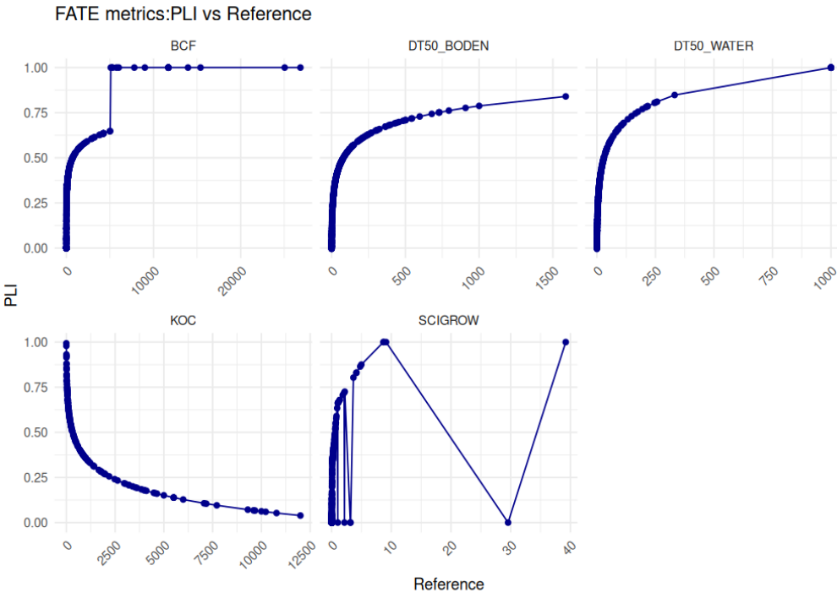

Figure 2: PLI-EUFate-metric calculated with the functions in Table 1 vs. values of the fate metrics

* + 1. Ecotoxicity load metrics

For ecotoxicity load metrics, the pesticide property value of a given active substance is expressed relative to a reference substance as suggested in Kudsk et al. (2018). In this study we suggest to use percentiles as reference values, which are based on all active substances considered in this study. These are based on data on pesticide sales reported to the Commission by Member States under [Regulation (EC) No 1185/2009](https://eur-lex.europa.eu/eli/reg/2009/1185/oj). In total there were **504** AS from which **468** could be linked to the PPDB by the EU-code. For all active substance ecotoxicity metrics (*EToxAI)* listed in Table 2, the reciprocal of both the parameter and the reference value is used, as a lower value indicates a higher risk.

*Where:*

Sub-indicator for one ecotoxicity metric

*ToxAS* ecotoxicity metric of an active substance parameter

*Toxr*ef Reference value of the ecotoxicity metrics

Following the discussion in our group, it was suggested that preserving the natural scaling of ecotoxicity metrics was more important than the potential distortion caused by extreme reference substance values. As a result, regulatory thresholds have not been applied to ecotoxicity load metrics.

The application of various reference values for standardizing ecotoxicity metrics was also examined in this study. Here we tested the PLI-EU calculation using the 10th, 5th, 1st percentiles, and the minimum as reference values, as outlined in Table 1. When percentiles are used as reference values, any active substances (ASs) with ecotoxicity values below the reference percentile will result in PLI values above 1. For example, if the 10th percentile is used as the reference, 10% of the ASs will have a PLI greater than 1 (Appendix Figure 7); if the 5th percentile is used, 5% will exceed a PLI of 1 (Figure 2), and if the 1st percentile is used, 1% will have a PLI greater than 1 (Appendix, Figure 5). If the Minimum is used as reference value this this not the case (Appendix Figure 4). However, to ensure that the calculated load indices remain within the range of zero to one, all toxicity parameters above the selected percentile value were set to one.

This means that the lower the percentiles chosen as the reference value, the fewer values will be characterized as one. However, choosing lower percentiles as reference values will result in lower PLI values for all other cases. In extreme cases (e.g., using the minimum as the reference value), the PLI distribution might show very few high values around one, with all other values falling within a low range of 0-0.2. By selecting higher percentiles, this issue can be avoided.

Compared to the original reference values used in the PLI definition by Kudsk et al. (2018), the 1st percentile values are consistently lower - except for the EC50 of algae (Table 6). In contrast, the 5th percentile values are generally more than 100 times higher than the reference values from Kudsk et al. (2018). This indicates that using the 5th percentile leads to a more conservative approach, as all PLI values calculated with it are higher than those derived from the 1st percentile or the original reference values. However, this increased conservatism comes at a cost: it results in categorizing the top 5% most toxic active substances with a maximum PLI of one, making it impossible to distinguish between them within that range.

Therefore, in this approach, we chose to use the 5th percentile as the reference value Figure 2 illustrates the PLI values calculated using the 5th percentile, plotted against the actual ecotoxicity metric values to demonstrate their distribution. In addition, the Appendix provides visualizations of the PLI distributions calculated using the minimum, 1st percentile, and 10th percentile reference values. (Figure 4 - Figure 7).

Table 7: Percentiles of ecotoxicity metrics as possible reference values for the PLI

|  |  |  |  |  |  |  |  |  |  |  |
| --- | --- | --- | --- | --- | --- | --- | --- | --- | --- | --- |
| Metrics | | Units | 10th percentile | 5th  percentile | 1st  percentile | minimum | PPDB High | Reference in Kudsk et al. | delta to 5th perc. | delta to 1st perc. |
| LC50_FISH | |  | 0,0371 | **0,004575** | 0,000101 | 0,000035 | 0,1 | 0,00021 | 2079% | -52% |
| LC50_AQU_INVERTEB. | |  | 0,0174 | **0,00178** | 0,000123 | 0,000045 | 0,1 | 0,0003 | 493% | -59% |
| LC50_SEDIMENTORG. | | | 0,00157 | **0,000402** | 2,15E-05 | 0,000013 | 0,1 |  |  |  |
| LC50_ALGEN | |  | 0,01336 | **0,00573** | 0,000319 | 0,00018 | 0,01 | 0,00002 | 2765% | 149% |
| EC50_LEMNA | |  | 0,00212 | **0,000962** | 0,000202 | 0,00004 | 0,01 | 0,00036 | 167% | -44% |
|  |  | | | | | | | | | |
| NOEC_FISH | |  | 0,00324 | **0,000716** | 3,00E-05 | 0,000004 | 0,01 | 0,00012 | 497% | -75% |
| NOEC_AQU_INVERTEB. | |  | 0,00188 | **0,000084** | 4,26E-06 | 1,6E-06 | 0,01 | 0,00012 | -30% | -96% |
| NOEC_SEDIMENTORG. | | | 0,00251 | **0,00042** | 9,15E-05 | 0,000047 | 0,01 |  |  |  |
|  |  | | | | | | | | | |
| LC50_REGENWURM | |  | 94,09 | **28,6395** | 5,587 | 1,13 | 10 | 3,4 | 742% | 64% |
| NOEC_REGENWURM | | | 0,9888 | **0,316** | 0,139 | 0,078 | 0,1 | 0,2 | 58% | -31% |
| NOEC_OTHER_SOILORG. | | | 1,54 | **0,26325** | 0,041207 | 0,012 |  |  |  |  |
|  |  | | | | | | | | | |
| LD50_BIRDS | |  | 249 | 72,125 | 11,318 | 5 | 100 | 49 | 47% | -77% |
| LD50_MAM_ORAL | |  | 158,4 | 63,3 | 10,298 | 8,7 | 100 | 20 | 217% | -49% |
| LD50_MAM_DER | |  | 158,4 | 63,3 | 10,298 | 8,7 | 100 |  |  |  |
|  |  | | | | | | | | | |
| LD50_BIENE_CONT | |  | 3,78 | **0,06016** | 0,003488 | 0,001 |  |  |  |  |
| LD50_BIENE_ORA | |  | 2,424 | **0,1708** | 0,004836 | 0,0037 | 1 | 0,02 | 754% | -76% |
| LD50_BUMBLEBEE_CONT | | | 0,1704 | **0,07** | 0,02051 | 0,005 |  |  |  |  |
| LD50_BUMBLEBEE_ORA | | | 0,1704 | **0,0749** | 0,02051 | 0,005 | 1 |  |  |  |
| LD50_MASONBEE_CONT | | | 0,057 | **0,035** | 0,0318 | 0,031 |  |  |  |  |
| LD50_MAS1ONBEE_ORA | | | 4,325 | **2,2875** | 0,6575 | 0,25 | 1 |  |  |  |
|  |  | | | | | | | | | |
| LR50_T_PYRI | |  | 2,4 | **0,2325** | 0,0022 | 0,0006 |  |  |  |  |
| LR50_A_RHOPA | |  | 2,835 | **0,3805** | 0,01776 | 0,002 |  |  |  |  |
| LR50_P_CUPREUS | |  | 3,4 | **3,3** | 2,725 | 2,45 |  |  |  |  |
| LR50_C_CARNEA | |  | 3,52 | **2,665** | 1,291 | 1,2 |  |  |  |  |
| LR50_C_SEPTEMP | |  | 3,27 | **0,885** | 0,26091 | 0,24 |  |  |  |  |
|  |  | | | | | | | | | |
| ER50_NTP1 | |  | 0,88082 | **0,40125** | 0,06696 | 0,054 |  |  |  |  |
| ER50_NTP2 | |  | 0,97646 | **0,40375** | 0,1645 | 0,07 |  |  |  |  |

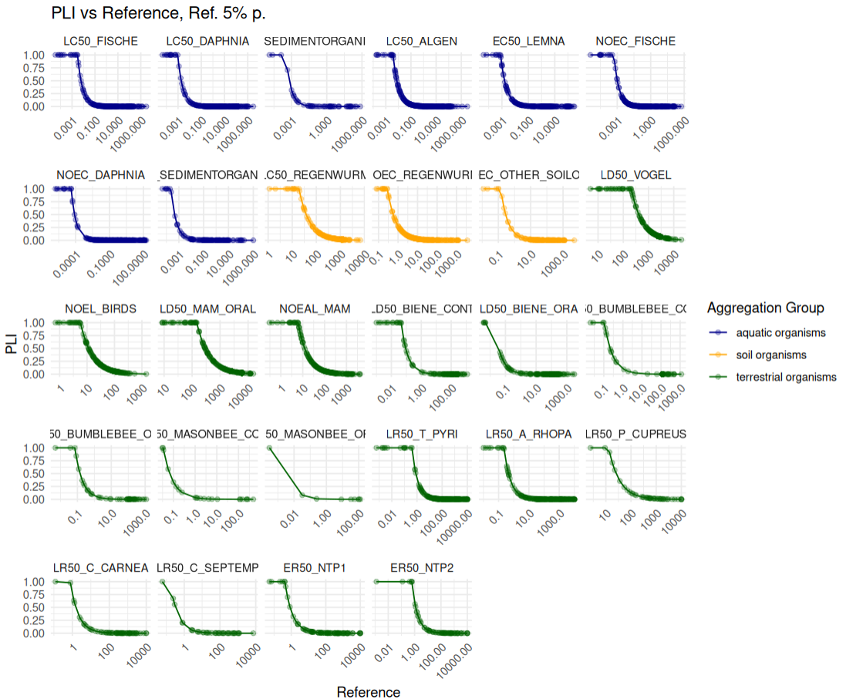

Figure 3: PLI-EUTox calculated with the 5th percentile as reference value vs. values of the ecotoxicity metrics

* + 1. Human health metrics

The original human health indicator *PLIHealth* is based on defined risk points, which are assigned according to the EU risk phrases (Kudsk et al., 2018).

An alternative approach to calculate is linked to the human health metrics listed in Table 3. The values of these metrics for each active substance is expressed relative to a reference value as derived in Kudsk et al. (2018) based on worst case substances. In this approach we suggest to use percentiles as reference values, which are based on all active substances considered in the study. These are 348 active substances which were sold in Germany since 2011. For all active substance ecotoxicity metrics (*HHAS)* listed in Table 3, the reciprocal of both the parameter and the reference value is used, as a lower value indicates a higher risk.

*where:*

Sub-indicator for one human health metric

*HHAS* human health metric of an active substance

*HHr*ef reference value of human health metrics

Table 8: Percentiles of human health metrics as possible reference values of the PLI

|  |  |  |  |  |  |
| --- | --- | --- | --- | --- | --- |
| **Metrics** | **Units** | **10th percentile** | **5th  percentile** | **1st  percentile** | **minimum** |
| Acceptable Operator Exposure Level(AOEL) |  | 0,005 | **0,00234** | 0,000528 | 0,0002 |
| Maximum Allowable Concentration: (MAC). |  | 0,1 | **0,1** | 0,01 | 0,01 |
| Acceptable Daily Intake: (ADI) |  | 0,005 | **0,0022** | 0,0004 | 0,0002 |
| Acute Reference Dose: (ARFD) |  | 0,0127 | **0,005** | 0,003685 | 0,001 |
| Lethal dose for 50% of mammals via oral exposure.(LD50 mam) |  | 158,4 | **63,3** | 10,298 | 8,7 |
| Lethal dose for 50% of mammals via dermal exposure. .(LD50 mam) |  | 2000 | **1027,5** | 351,39 | 40 |

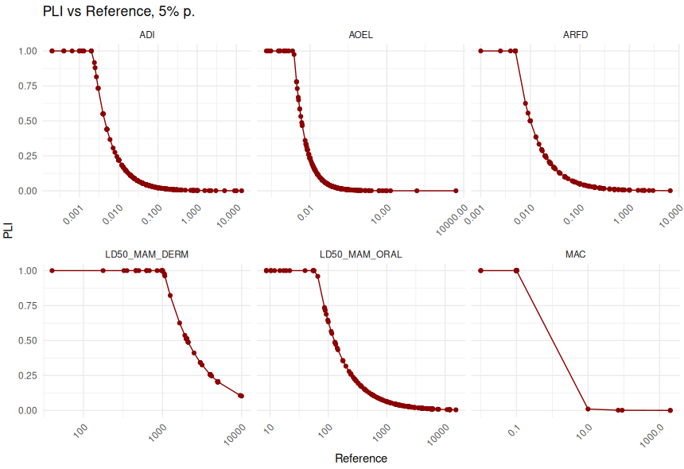

Figure 4: PLI-EUHuman calculated with the 5st percentile as reference value vs. human health metrics

* 1. Aggregation of the *PLI-EU*
     1. Aggregation of the ecotoxicity load metrics

The aggregation process will be carried out in four distinct steps (Table 8). In the first step, we have chosen to select the minimum toxic value, or more specifically, the worst-case scenario, for a group of reference organisms that inhabit the same environmental compartment and constitute a homogeneous group. These reference organisms include aquatic plants, soil organisms, terrestrial plants, pollinators, mammals, and beneficial organisms.

By selecting the worst-case organism within a homogeneous group, we can reduce the occurrence of missing values in aggregated organism group data. For example, the two metrics for aquatic plants show data availability of 92% for algae and only 58% for Lemna. As a result, many active substances have values for algae but none for *Lemn*a. This is expected, as Lemna tests are typically only conducted when algae toxicity is relatively high. By applying the worst-case toxicity approach - using the more sensitive value between the two metrics - we can still incorporate Lemna data, despite its lower availability. However, this also means we implicitly assume that for all missing Lemna data, its toxicity is less severe than that of algae. The strong correlation between the two metrics (R² = 0.68) for active substances where both values are available supports this assumption, indicating they generally reflect similar trends. Therefore, this approach does not unfairly favour active substances that only have algae data.

For beneficial organisms, the highest data availability is observed for *T. pyri* (72%) and *A. rhopalosiphi* (71%). The additional three species have significantly lower data availability, ranging from 12% to 26%. This disparity is due to the fact that *T. pyri* and *A. rhopalosiphi* are typically the standard test species used during active substance registration. The correlation between these two organisms is relatively low (R² = 0.3). However, since their data availability is nearly identical, the use of one over the other in the presence of missing values will not favour any particular active substance. Additionally, the correlation between *A. rhopalosiphi* and the other beneficial organisms is comparatively higher.

Text for bees and terrestrial plants is still missing!! Correlations in Appendix are strange? For terrestrial plants a problem with the data import from PPDB happened (NTP1 =NTP2).

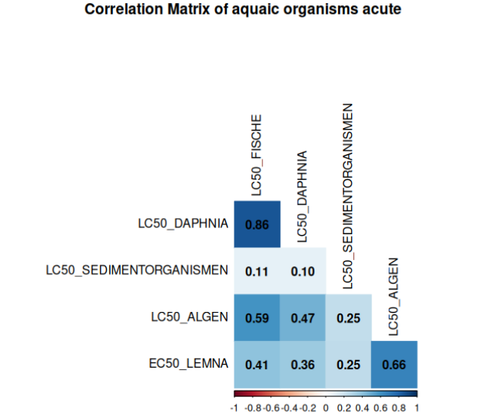 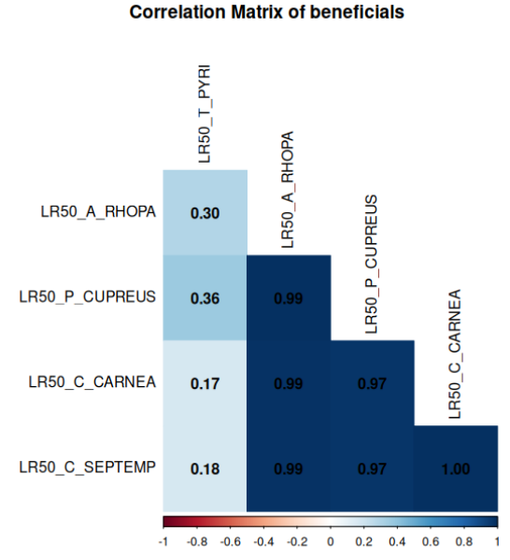

Figure 5: Correlation matrix of metrics for acute aquatic toxicity and beneficial organisms

In the second aggregation step, these initial values are grouped further. Aquatic organisms are grouped into acute and chronic categories, based on four and three metrics respectively (see Table 8). Vertebrates are calculated as the average of two mammalian metrics, while pollinators, beneficial organisms and plants are maintained as separate groups.

In the second and third aggregation levels, we chose to aggregate using averages, as the groups involved are relatively heterogeneous. In these cases, we are grouping different organisms that inhabit distinct ecological compartments. By calculating the average, we ensure that an active substance with high toxicity for one metric and low toxicity for another will result in a lower PLI than an a.i. that shows high toxicity across multiple metrics.

For example, if herbicide A is highly toxic to aquatic plants but shows low toxicity to the other three aquatic organisms, it should receive a lower PLI than a herbicide that, in addition to being highly toxic to aquatic plants, also exhibits high toxicity toward one or more of the other aquatic organisms. Given the heterogeneity of the groups at aggregation levels 2, 3 and 4 we do not expect strong correlations between the metrics of each group. Using averaging as the aggregation method, rather than selecting the worst-case value, does not create an unfair advantage for an active substance with missing data.

Table 9: Aggregation of the ecotoxicity load metrics

In the third aggregation step, broader ecological categories are formed. Aquatic organisms are obtained by averaging the acute and chronic scores. Soil organisms are calculated by averaging three relevant organism groups. Terrestrial organisms are derived by averaging the scores for vertebrates, pollinators, beneficial organisms, and plants. Finally, in the fourth and last aggregation step, the overall PLI Toxicity score is calculated by averaging the scores of the three main ecosystem-level groups: aquatic organisms, soil organisms, and terrestrial organisms. This method ensures a balanced and comprehensive representation of ecological toxicity across multiple environmental compartments.

* + 1. Aggregation of the fate load metrics

The *PLIFate* score is calculated through a two-step aggregation process. In the first step, four individual metrics are grouped and averaged: two each for Persistence (e.g., DT50 soil and DT50 water) and Leachability. In the second step, the average values of Persistence, Leachability, Bio-Concentration, and Mobility are combined using a simple average to determine the overall PLI Fate score.

Because the fate metrics differ significantly, and the first aggregation step involves combining inherently heterogeneous parameters (e.g., *DT50soil* vs. *DT50water*), we do not expect strong correlations among the components. For this reason, averaging was chosen as the aggregation method.

Table 10: Aggregation of the fate load metrics



* + 1. Aggregation of the human load metrics

The *PLIHumanHealth* score is calculated through a multi-step aggregation process. First, three groups - Operators, Consumers, and Mammals - each aggregate two toxicity-related metrics using a worst-case (minimum) approach. These three results are then averaged to produce the PLI Human Health based on toxicity. Separately, a General group is assessed based on risk phrases without further aggregation, resulting in the PLI Human Health based on risk phrases. Finally, the overall PLI Human Health score is obtained by averaging the toxicity-based and risk phrase-based scores.

Text for correlations is still missing.

1. Operator : Drop MAC?
2. Consumers: Moderate correlation among metrics. No suggestion needed
3. Mammals: Drop Mammals Dermal!! Strange values! Also for Ecotoxicity

|  |  |  |
| --- | --- | --- |
|  |  |  |

Table 11: Aggregation of the human load metrics



* 1. Active substance database for the *PLI-EU* calculation: PPDB vs. EFSA

**Text to be written**

References

Rainford, J, Tzilivakis, J., Garthwaite, D., Jones, G. and Lewis, K.A. (2022) Finalising a Pesticide Load Indicator for the UK: Technical report. Prepared for the Department for Environment, Food and Rural Affairs (Defra), UK, for project PC0107, by FERA Science Ltd and the Agriculture and Environment Research Unit (AERU), University of Hertfordshire, UK)

Rainford, J, Kennedy M. and Jones, G.2021. “Pesticide Risk Indices: A Review of Practical Implications for Policy and Interpretation.” Critical Review. FERA Science Limited on behalf of the [UK] National Farmers Union. https://www.nfuonline.com/archive?treeid=151098.

Rainford, J, Tzilivakis, J., Garthwaite, D., Jones, G. and Lewis, K.A. (2022a). “A Pesticide Load Indicator for the UK: Final Report. Prepared for the Department for Environment, Food and Rural Affairs (Defra), UK, for Project PC0107, by FERA Science Ltd and the Agriculture and Environment Research Unit (AERU), University of Hertfordshire, UK.”

Danish Environmental Protection Agency. (2012). *The Agricultural Pesticide Load in Denmark 2007-2010* (Report No. 978-87-92779-96-0). Retrieved from <https://www2.mst.dk/Udgiv/publikationer/2012/03/978-87-92779-96-0.pdf>

Dorne, J. L. C. M., Richardson, J., Livaniou, A., Carnesecchi, E., Ceriani, L., Baldin, R., Kovarich, S., Pavan, M., Saouter, E., Biganzoli, F., Pasinato, L., Zare Jeddi, M., Robinson, T. P., Kass, G. E. N., Liem, A. K. D., Toropov, A. A., Toropova, A. P., Yang, C., Tarkhov, A., … Bassan, A. (2021). *EFSA’s OpenFoodTox: An open source toxicological database on chemicals in food and feed and its future developments*. *Environment International, 146*, 106293. <https://doi.org/10.1016/j.envint.2020.106293>

Kudsk, P., Aaslyng, M. D., & Jørgensen, B. M. (2018). An R package to calculate potential environmental and human health impacts of pesticide use in Denmark. *Science of the Total Environment, 615*, 1234–1243. https://doi.org/10.1016/j.scitotenv.2017.09.149

Williams, A. J., Grulke, C. M., Edwards, J., McEachran, A. D., Mansouri, K., Baker, N. C., Patlewicz, G., Shah, I., Wambaugh, J. F., Judson, R. S., & Richard, A. M. (2017). The CompTox Chemistry Dashboard: a community data resource for environmental chemistry. *Journal of Cheminformatics*, 9, 61. [ACS Publications+4US EPA+4Wikipedia+4](https://www.epa.gov/comptox-tools/chemicals-dashboard-help-references?utm_source=chatgpt.com)

U.S. Environmental Protection Agency (EPA). CompTox Chemicals Dashboard. Retrieved

Dorne, J.L.C.M., Richardson, J., Livaniou, A., Carnesecchi, E., Ceriani, L., Baldin, R., Kovarich, S., Pavan, M., Saouter, E., Biganzoli, F., Pasinato, L., Zare Jeddi, M., Robinson, T.P., Kass, G.E.N., Liem, A.K.D., Toropov, A.A., Toropova, A.P., Yang, C., Tarkhov, A., Georgiadis, N., Di Nicola, M.R., Mostrag, A., Verhagen, H., Roncaglioni, A., Benfenati, E., & Bassan, A. (2021). EFSA's OpenFoodTox: An open source toxicological database on chemicals in food and feed and its future developments. *Environment International*, 146, 106293. [European Food Safety Authority+7PubMed+7Zenodo+7](https://pubmed.ncbi.nlm.nih.gov/33395940/?utm_source=chatgpt.com)

European Food Safety Authority (EFSA). OpenFoodTox: Chemical Hazards Database. Retrieved from <https://www.efsa.europa.eu/en/data-report/chemical-hazards-database-openfoodtox> [European Food Safety A](https://www.efsa.europa.eu/en/data-report/chemical-hazards-database-openfoodtox?utm_source=chatgpt.com)

U.S. Environmental Protection Agency (EPA). *SCI-GROW User’s Manual: Screening Concentration in Ground Water Model*. Version 2.3, 2001. Zugegriffen am Tag Monat Jahr. <https://archive.epa.gov/oppefed1/web/html/scigrow_users_manual.html>

European Chemicals Agency (ECHA). (2017). *Guidance on information requirements and chemical safety assessment: Chapter R.11: PBT/vPvB assessment* (Version 3.0). Retrieved from <https://echa.europa.eu/documents/10162/13643/information_requirements_r11_en.pdf>

1. Appendix
   1. Comparison of toxicity metrics with PLI-EU values based on different reference values
      1. PLI-EU with minimum as reference value

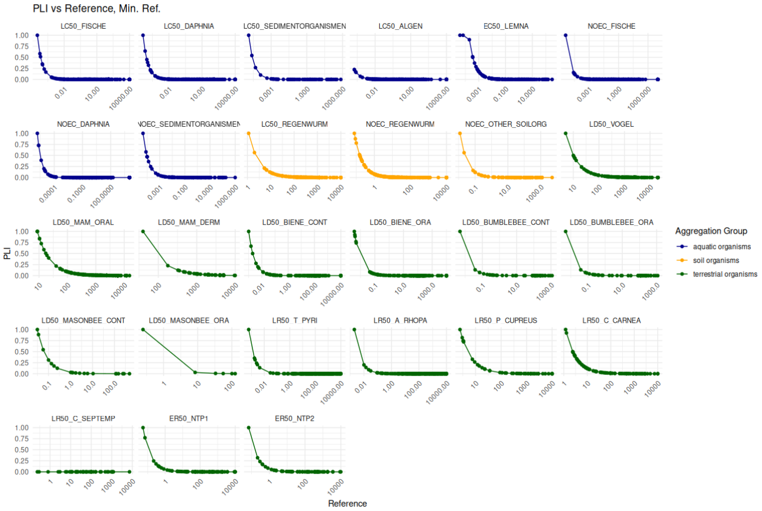

Figure 6: PLI-EUTox calculated with the minimum as reference value vs. ecotoxicity metrics

* + 1. PLI-EU with 1th percentile as reference value

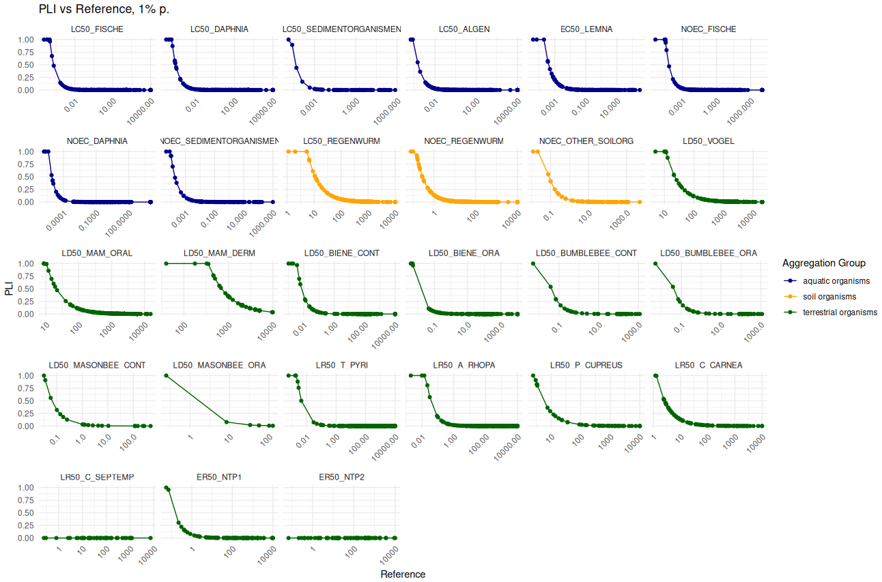

Figure 7: PLI-EUTox calculated with the 1st percentile as reference value vs. ecotoxicity metrics

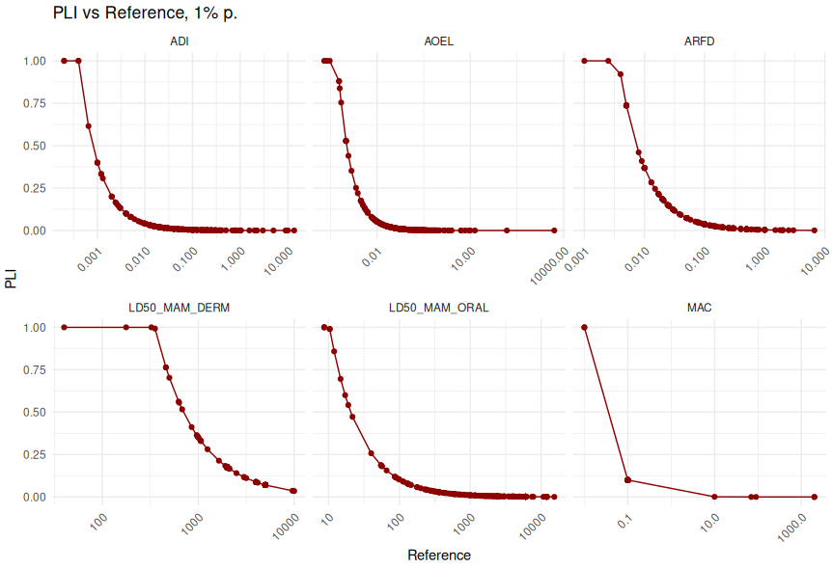

Figure 8: PLI-EUHuman calculated with the 1st percentile as reference value vs. human health metrics

* + 1. PLI-EU with 10th percentile as reference value

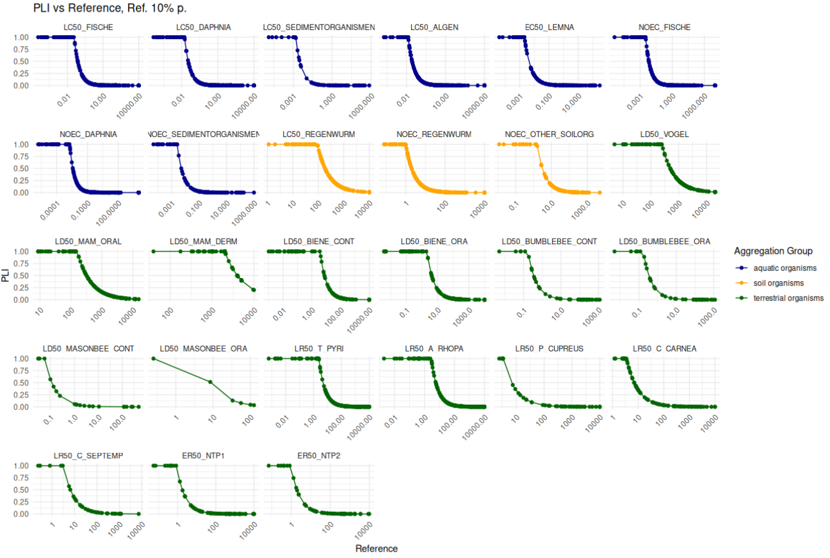

Figure 9: PLI-EUTox calculated with the 10th percentile as reference value vs. ecotoxicity metrics

* 1. Correlation between pollinators.

All metrics highly correlated. No suggestion needed.

**That actually can't be the case - when I plot the data against each other, I can't see any correlations of 1.**

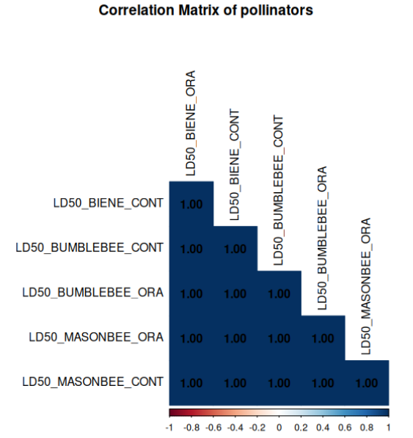

* 1. Correlation terrestrial plants

Very high correlation. No suggestions needed.

**→> here a mistake happened when iporting the PPDB data into oracle**

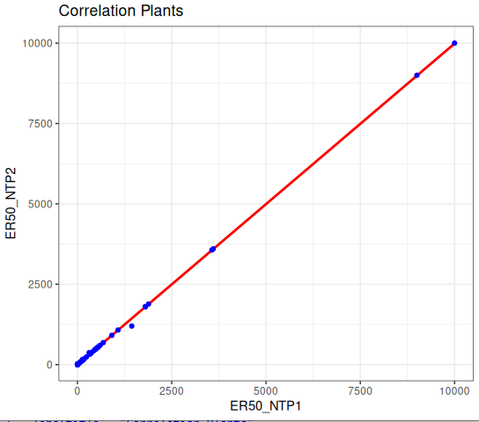

* 1. Summary of all metrics

To be translated and copleted completed.

Table 12: Zusammenfassung der für die Berechnung notwenigen Parameter und Grunddaten zu den Indikatoren PLI und RIP. Die Anzahl und Anteile der Wirkstoffparameter, für die ein Wert in der PPDB vorliegt beziehen sich auf eine Gesamtzahl von 314 Wirkstoffen (seit 2011 zugelassen).

| **Indikator** | **PLI** | **RIP** | **Parameter** | **Daten-quelle** | **Anzahl mit Wert in PPDB1** | **Anteil mit Wert in PPDB2** | **Referenz- wert** | **Formel** | **Formel für Abbaufaktor** |
| --- | --- | --- | --- | --- | --- | --- | --- | --- | --- |
| **Auswirkungen auf die menschliche Gesundheit** |  |  |  |  |  |  |  |  |  |
| **AOEL** |  |  |  | PPDB | 272 | 0,83 | 0,002265 |  |  |
| **ADI** |  |  |  | PPDB | 267 | 0,81 | 0,00212 |  |  |
| **Formulierung** | **X** | **X** |  | PPDB |  |  |  |  |  |
| **Risk Code** | **X** | **X** |  | PPDB |  |  |  |  |  |
| **Auswirkungen auf die Umwelt (Toxizität)** |  |  |  |  |  |  |  |  |  |
| **Säugetiere oral** | **X** | **X** |  | PPDB | 288 | 0,88 | 56,35 |  |  |
| **Vögel** | **X** | **X** |  | PPDB | 300 | 0,91 | 70,55 |  |  |
| **Aquatische Pflanzen (Wasserlinse)** |  | **X** |  | PPDB | 198 | 0,6 | 0,000941 |  |  |
| **Algen** | **X** | **X** |  | PPDB | 311 | 0,95 | 0,0055 |  |  |
| **aquatische Invertebraten** | **X** | **X** |  | PPDB | 313 | 0,95 | 0,0015 |  |  |
| **FISH** | **X** | **X** |  | PPDB | 314 | 0,95 | 0,00426 |  |  |
| **Marienkäfer (NTA1)** |  | **X** |  | PPDB | 52 | 0,16 | 3,3 |  |  |
| **Raubmilben (NTA2 )** |  | **X** |  | PPDB | 247 | 0,75 | 0,179 |  |  |
| **Parasitische Wespen (NTA3 )** |  | **X** |  | PPDB | 244 | 0,74 | 0,403 |  |  |
| **Florfliegen (NTA4)** |  | **X** |  | PPDB | 92 | 0,28 | 2,665 |  |  |
| **Bodenkäfer (NTA5)** |  | **X** |  | PPDB | 43 | 0,13 | 0,3419 |  |  |
| **Nicht-Ziel Pflanze (NTP1)** |  | **X** |  | PPDB | 81 | 0,25 | 0,4 |  |  |
| **Nicht-Ziel Pflanze (NTP2 )** |  | **X** |  | PPDB | 63 | 0,19 | 0,4025 |  |  |
| **Honigbiene oral** | **X** | **X** |  | PPDB | 296 | 0,9 | 0,1575 |  |  |
| **Hummel oral** |  | **X** |  | PPDB | 48 | 0,15 | 0,0749 |  |  |
| **Mason Bee oral** |  | **X** |  | PPDB | 6 | 0,02 | 2,2875 |  |  |
| **Regenwürmer** | **X** | **X** |  | PPDB | 303 | 0,92 | 20,365 |  |  |
| **FISH** | **X** | **X** |  | PPDB | 296 | 0,9 | 0,000675 |  |  |
| **Sedimentorganismen** | **X** | **X** |  | PPDB | 155 | 0,51 | 0,000296 |  |  |
| **aquatische Invertebraten** | **X** | **X** |  | PPDB | 296 | 0,9 | 0,000675 |  |  |
| **Regenwürmer** | **X** | **X** |  | PPDB | 273 | 0,83 | 0,304 |  |  |
| **Umwelteigenschaften der Wirkstoffe (Umwelteigenschaften)** |  |  |  | PPDB |  |  |  |  |  |
| **BCF** | **X** | **X** |  | PPDB | 314 | 0,95 | 3087,5 |  |  |
| **DT50 Boden** | **X** | **X** |  | PPDB | 299 | 0,91 | 367,1 |  |  |
| **DT50 Wasser** |  | **X** |  | PPDB | 272 | 0,83 | 184,07 |  |  |
| **DT50 Pflanze** |  | X |  | PPDB | 68 | 0,21 | 33,11 |  |  |
| **GUS  Leaching potential** |  | X |  | berechnet |  |  |  |  |  |
| **SCI GROW  groundwater index** | **X** | **X** |  | berechnet | 288 | 0,88 | 0,87503 |  |  |

Correlations – Ecotoxic metrics

**Vera, do you think it is possible to arange the pots in a verical layout with a bit more sytematic to the order of the metrics? For example as suggested below?**



